Sales forecasting prediction

Abstract
Sales forecasting is a complex task that involves analyzing historical data, market trends, and other factors to predict future sales. Traditional statistical models often fall short in capturing the nonlinear relationships and complexities involved. This study explores the application of Artificial Intelligence (AI) techniques, such as Machine Learning (ML) and Deep Learning (DL), to improve sales forecast prediction.
Introduction
Accurate sales forecasting is crucial for businesses to make informed decisions about inventory management, marketing strategies, and resource allocation. However, the volatile nature of sales data and its dependence on multiple external factors make it a considerable challenge. Traditional methods have limitations, and AI techniques offer a promising solution.
Objectives
- Analyze historical sales data to identify meaningful patterns
- Apply AI models (ML and DL) for sales forecast prediction
- Evaluate the performance of different models and determine the most effective one
- Incorporate sentiment analysis from customer feedback and market trends to enhance forecasting accuracy
Methodology Data Collection
- Data Source: Historical sales data from internal databases or external sources
- Period: 2015-2025
- Attributes: Sales volume, revenue, seasonality, and other relevant factors
- Sentiment Data: Customer feedback, reviews, and market trends
Data Preprocessing
- Removal of missing or noisy data
- Normalization using Min-Max scaling to bring all features into the range [0,1]
- Generation of technical indicators such as moving averages and seasonal decomposition
- Sentiment scoring using NLP models (e.g., FinBERT)

Feature Engineering
- Time-series features created using rolling windows (e.g., last 60 days' sales data)
- Sentiment scores merged with historical sales data
Model Development
- Linear Regression - baseline statistical model
- Random Forest Regressor - ensemble-based ML model
- LSTM Neural Network - deep learning model suitable for sequential data
Model Evaluation
Metrics used: Mean Absolute Error (MAE), Root Mean Squared Error (RMSE), R² Score, and Directional Accuracy
Limitations
- Limited historical and sentiment data availability
- Overfitting risk due to small sample size
- External factors like economic downturns or sudden crises remain unpredictable
Future Work
- Incorporating transformer-based architectures (e.g., Time Series BERT, GPT models)
- Using reinforcement learning for dynamic sales strategy optimization
- Expanding sentiment analysis with multimodal data (text, images, videos)
- Real-time prediction dashboards for sales teams and analysts

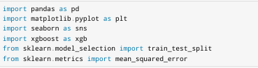
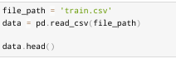
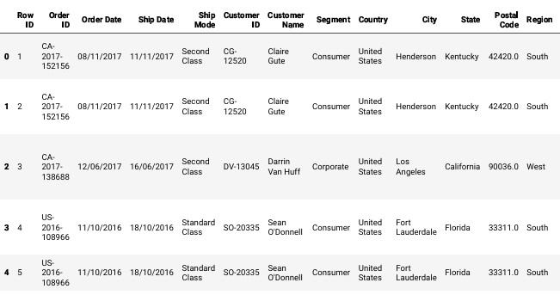
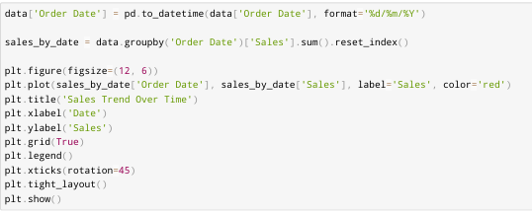
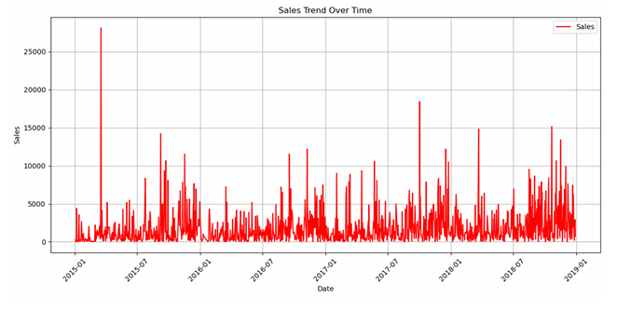
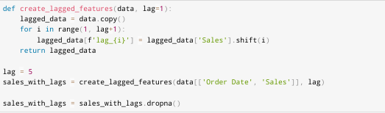
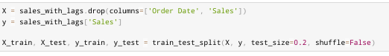
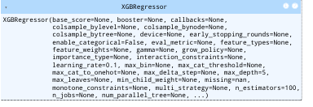
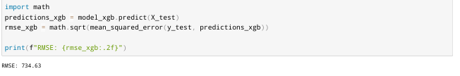

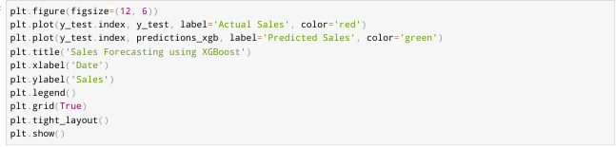
Output
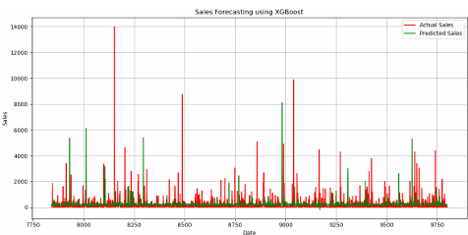
Scope
The scope of this study is focused on applying Artificial Intelligence (AI) techniques to predict future sales trends and movements. The research emphasizes how AI—particularly Machine Learning (ML) and Deep Learning (DL) models—can analyze large volumes of sales data to generate more accurate and data-driven forecasts.
Conclusion:
The results show that the accuracy achieved by the ML model is not significantly better than random chance. Possible reasons for this may be the lack of relevant data or using a simple model to perform the complex task of sales forecasting. Further research is needed to improve model complexity and incorporate additional data sources.

THANK YOU

NAME=ANANDA SM
COURSE=COMPUTER SCIENCE & AI/ML
EMAILID=iamanand.info@gmail.com

